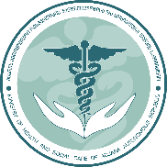
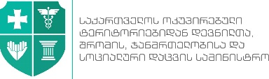
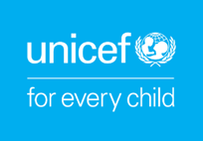
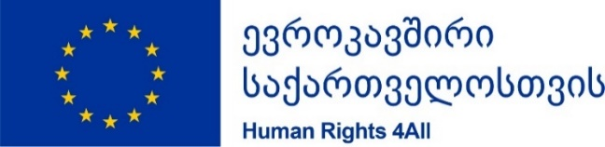

Enhancing Child Development-Oriented Primary Healthcare in Adjara
29 March 2018, Batumi
Agenda
Event # 1 | Presentation of the Child development-oriented primary healthcare in Adjara – press-conference  Batumi, hotel TBC
11:00 – 11:20 | Opening of the event  Welcoming speeches  Minister of Health, Adjara  UNICEF Representative  MoIDPLHSA Representative  EU Representative
11:20 – 11:35 | Presentation  Child Development oriented primary healthcare in Adjara  Tamar Ugulava, UNICEF Health Specialist
11:35 – 11:45 | Questions & Answers
11:45 – 12:00 | Media interviews with speakers and health professionals
11:45 – 12:45 | Lunch
Event #2 | Visit to the Trainings of primary health care professionals in Batumi. MedCentre
13:40 – 14:00 | Visit the ongoing trainings of the Adjara primary health care professionals – One of the medical centre in Batumi
14:00 – 14:15 | Welcome training participants
14:15 – 14:45 | Questions & Answers Moderated by Tamar Ugulava
Event # 3 | Visit to a family - Khelvachauri
14:45 – 15:10 | Departure to Khelvachauri to accompany a primary health professional on her visit to a family
15:10 – 15:40 | Visit to a family
15:40 | Departure to Batumi

Photos/video will be taken during the events.

